**Department With Highest Average Salary**

CREATE TABLE DEP(DEP_ID INT PRIMARY KEY,DEP_NAME VARCHAR(20));

INSERT INTO DEP VALUES(1,'IT');

INSERT INTO DEP VALUES(2,'Finance');

INSERT INTO DEP VALUES(3,'Marketing');

INSERT INTO DEP VALUES(4,'Sales_Executive');

SELECT * FROM DEP;

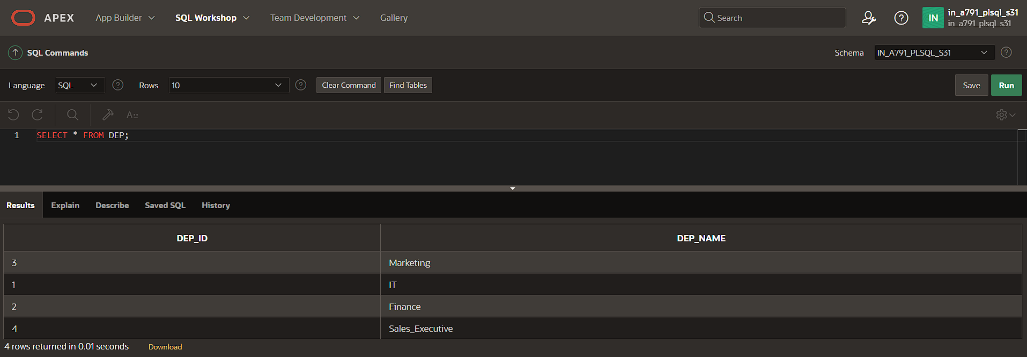

CREATE TABLE EMP(EMP_ID INT PRIMARY KEY,EMP_NAME VARCHAR(20),SALARY INT,DEP_ID INT,FOREIGN KEY (DEP_ID) REFERENCES DEP (DEP_ID));

INSERT INTO EMP VALUES(100,'Vinoth',45000,1);

INSERT INTO EMP VALUES(101,'Vasanth',55000,2);

INSERT INTO EMP VALUES(103,'Ben',35600,3);

INSERT INTO EMP VALUES(104,'Kevin',75000,4);

SELECT * FROM EMP;

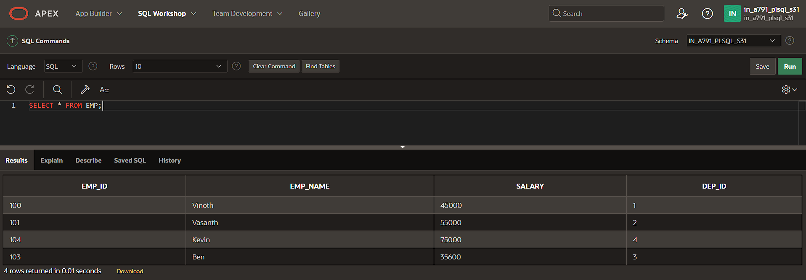

SELECT d.DEP_ID, d.DEP_NAME, AVG(e.salary) AS AVG_salary

FROM DEP d

JOIN EMP e ON e.DEP_ID = d.DEP_ID

GROUP BY d.DEP_ID, d.DEP_NAME

ORDER BY AVG_salary DESC;

